🌱 Day 2 — How is Data Organized & Stored?

Quick Recap of Yesterday 🔄
Day 1 You Learned:
✅ Data = Any recorded fact about the world
✅ You generate data every single day
✅ Companies use data to answer questions
✅ Data journey → Collection → Clean → Analyze → Decision
Today we go one level deeper. Yesterday you understood WHAT data is. Today you'll understand HOW it's organized— because messy data is useless data.

🏗️ Start With This Analogy
Imagine a library.
A library has thousands of books. If all those books were just thrown on the floor randomly — finding anything would be impossible.
But libraries organize ooks by:
- Section (Fiction, Science, History)
- Shelf (Author's last name)
- Order (Alphabetical)

Databases and data storage work exactly the same way. Data needs organization before it becomes useful.

📋 Part 1: How Data is Organized — The Table
The most fundamental way data is organized is a TABLE.
You already saw tables in EDA. Now let's truly understand every part of it.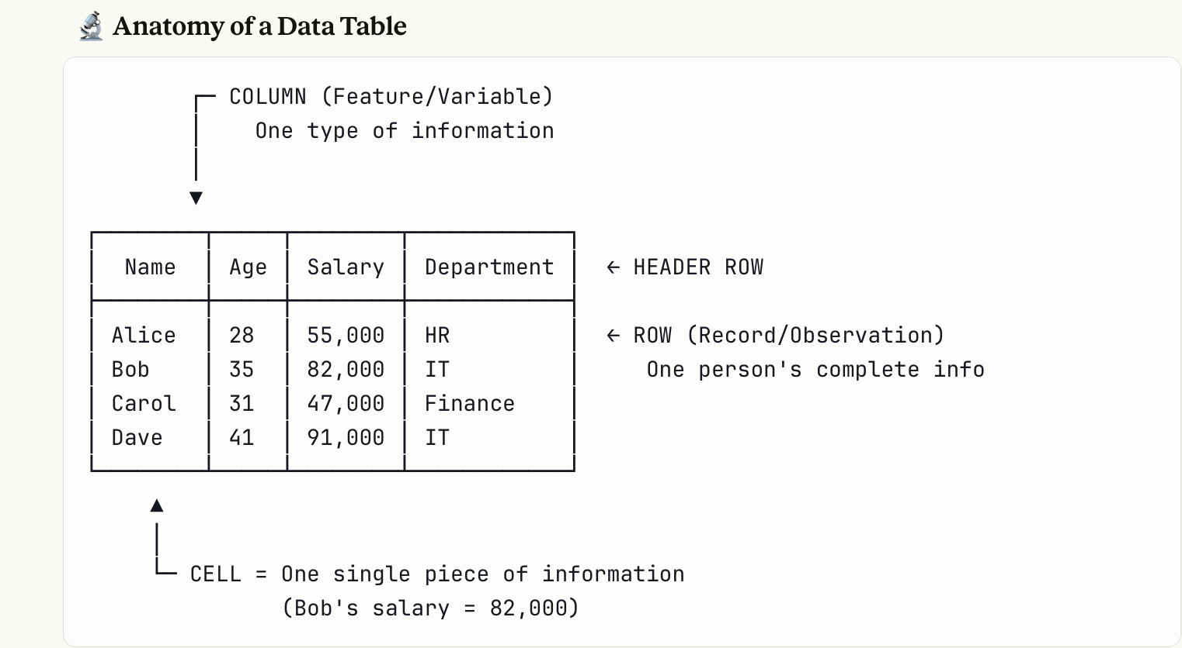

In simple words:
- Row = One complete record → Everything about ONE person/thing
- Column = One type of information → ONE characteristic across everyone
- Cell = The intersection → One specific fact about one specific person

🌍 Real Life Table Examples

- Bank Transaction Table:

- | TransactionID | Date | Amount | Type | Merchant |
- |---------------|------------|--------|---------|-------------|
- | TXN001 | 01-Jan-24 | ₹250 | Debit | Swiggy |
- | TXN002 | 01-Jan-24 | ₹5000 | Credit | Salary |
- | TXN003 | 02-Jan-24 | ₹180 | Debit | Ola |
- Each row = one transaction Each column = one detail about that transaction

Hospital Patient Table:
- | PatientID | Name | Age | Disease | AdmitDate | DaysStayed |
- |-----------|-------|-----|-----------|------------|------------|
- | P001 | Rahul | 45 | Diabetes | 10-Jan-24 | 5 |
- | P002 | Priya | 32 | Fracture | 11-Jan-24 | 3 |
- | P003 | Ahmed | 67 | Cardiac | 11-Jan-24 | 12 |
- 💡 Key insight: Every industry — hospitals, banks, schools, retail stores — organizes their data in tables. The format is universal. Once you understand one table, you understand all of them.

🔑 Part 2: The Most Important Column — Primary Key
Every good table has one column that makes each row completely unique.
This is called the Primary Key.

Why Do We Need It?

Story:
Imagine a school has 3 students all named "Rahul Sharma." How does the system know which Rahul got which marks? Which Rahul paid fees? Which Rahul was absent?
If you only use names — it's chaos.
So every school assigns a unique Roll Number to each student.
| Roll No | Name | Marks | Attendance |
|---------|--------------|-------|------------|
| 101 | Rahul Sharma | 85 | 92% |
| 102 | Rahul Sharma | 71 | 78% |
| 103 | Rahul Sharma | 90 | 95% |
Now Roll No 101, 102, 103 are perfectly separated. No confusion.
Real world Primary Keys:
System | Primary Key
Bank | Account Number
Hospital | Patient ID
School | Roll Number
E-commerce | Order ID
Government | Aadhar Number
Company | Employee ID
💡 Rule: A Primary Key must be UNIQUE (no two rows have the same value) and never EMPTY (every row must have one).

🔗 Part 3: How Tables Talk to Each Other — Relationships
Here's where it gets interesting. In real life, data is never just ONE table.
Think about Amazon. They don't store everything in one giant table. They have MANY tables that are connected to each other.

The Restaurant Analogy 🍽️
Imagine a restaurant has:
- A Customer List (who they are)
- An Order List (what was ordered)
- A Menu List (what's available)
These are 3 separate tables. But they're connected:
CUSTOMERS TABLE ORDERS TABLE MENU TABLE
┌──────┬───────┐ ┌────────┬──────┬─────┐ ┌────────┬────────┬───────┐
│CustID│ Name │ │OrderID │CustID│ItemID│ │ ItemID │ Item │ Price │
├──────┼───────┤ ├────────┼──────┼─────┤ ├────────┼────────┼───────┤
│ C1 │ Alice │←──┐ │ O1 │ C1 │ M2 │─┐│ M1 │ Pizza │ ₹350 │
│ C2 │ Bob │ └───│ O2 │ C1 │ M1 │ ││ M2 │ Burger │ ₹180 │
│ C3 │ Carol │ │ O3 │ C2 │ M3 │ └│ M3 │ Pasta │ ₹280 │
└──────┴───────┘ └────────┴──────┴─────┘ └────────┴────────┴───────┘
Alice (C1) ordered a Burger (M2) and Pizza (M1). The tables are linked by IDs.
This is called a Relational Database — tables that are connected through common IDs.

💡 Why not put everything in one table? If you put customer info + order info + menu info in one table, Alice's name and address would repeat 50 times if she made 50 orders. That's wasteful and messy. Separate tables = clean and efficient.

🗄️ Part 4: Where is Data Actually Stored?
Now you know how data is organized. But where does it physically live?

Storage Level 1: Spreadsheet (Excel / Google Sheets)
Who uses it: Small businesses, students, individuals
Size: Hundreds to thousands of rows
Example: A small shop tracking daily sales
Limitation: Can't handle millions of rows
Think of this as a notebook — great for personal use, not for a large company.

Storage Level 2: Database (SQL — the most common)
Who uses it: Most companies — banks, hospitals, startups
Size: Millions to billions of rows
Example: A bank storing all customer transactions
How to access: Using a language called SQL
Think of this as a filing cabinet with a smart system — organized, searchable, can handle huge amounts of data.
The most common databases you've heard of:
- MySQL
- PostgreSQL
- Oracle
You don't need to know HOW to use them yet. Just know they exist and that almost every company uses one.

Storage Level 3: Data Warehouse
Who uses it: Large companies — Flipkart, Zomato, Airtel
Size: Billions to trillions of rows
Purpose: Combining data from MANY databases for analysis
Example: Flipkart combining sales + customer + delivery data
all in one place for analysis
Think of this as a giant central library that collects books from many smaller libraries.

Storage Level 4: Data Lake
Who uses it: Very large companies — Google, Amazon, Meta
Size: Petabytes (unimaginably large)
Purpose: Store EVERYTHING — structured AND unstructured
Example: Google storing every search, click, video watch,
voice query, map direction ever made
Think of this as an ocean — everything goes in. Structured data, unstructured data, videos, images, text — all together.

Simple Visual Summary:
SIZE & COMPLEXITY
▲
│
Data Lake │ 🌊 Store everything, any format
│
Data │ 🏛️ Combined data for company-wide analysis
Warehouse │
│
Database │ 🗄️ Organized tables, millions of rows
│
Spreadsheet │ 📋 Simple tables, thousands of rows
│
└──────────────────────────────────→
MOST COMPANIES START HERE

📊 Part 5: Types of Data — Deeper Than Day 1
In Day 1 you learned Structured vs Unstructured. Now let's go deeper.

🕐 Type 1: Static Data vs Dynamic Data
Static Data — Data that doesn't change often
Examples:
- Your date of birth
- Country of origin
- Employee joining date
- Product category
Dynamic Data — Data that changes constantly
Examples:
- Stock prices (changes every second)
- Your location (changes as you move)
- Temperature (changes every minute)
- Website visitors right now
💡 This matters because static data can be analyzed calmly. Dynamic data needs real-time systems that update constantly.

🕐 Type 2: First Party vs Second Party vs Third Party Data
First Party Data — Data YOU collected about YOUR customers
Example: Zomato tracking what YOU order, when, how often
Most valuable — most accurate about your own users
Second Party Data — Data shared between partners
Example: Zomato sharing delivery zone data with Google Maps
Useful when you trust the partner
Third Party Data — Data bought from outside sources
Example: A company buying demographic data from a research firm
Useful for reaching new audiences
Least reliable — you don't control how it was collected

🕐 Type 3: Quantitative vs Qualitative (Important!)
 | Quantitative | Qualitative
What it is | Can be measured with numbers | Describes qualities, not numbers
Examples | Height, Weight, Sales, Score | Reviews, Opinions, Colors, Emotions
Question it answers | How many? How much? | Why? What kind? How was it?
Analysis | Calculate averages, graphs | Read themes, find patterns in words
Story:
A restaurant gets 1000 reviews. The star rating (1-5) is quantitative — you can average it. But the written review "The naan was cold and the waiter was rude" is qualitative — you need to read it and find themes.
Both matter. Stars tell you HOW BAD. Written reviews tell you WHY.

🧩 Part 6: The Data Ecosystem — How Everything Connects
Now let's zoom out and see the full picture of how data flows in a real company:
WORLD
│
│ People buy, click, search, talk, move
▼
DATA SOURCES
├── Website clicks
├── App usage
├── Transactions
├── Customer forms
├── Social media
└── Sensors / IoT devices
│
▼
DATA COLLECTION
│ (APIs, forms, tracking pixels, sensors)
▼
DATA STORAGE
├── Spreadsheet (small)
├── Database (medium)
├── Data Warehouse (large)
└── Data Lake (massive)
│
▼
DATA CLEANING
│ (Fix errors, handle missing values ← EDA!)
▼
DATA ANALYSIS
│ (Find patterns, answer questions ← EDA + Statistics!)
▼
DATA VISUALIZATION
│ (Charts, dashboards, reports)
▼
INSIGHTS & DECISIONS
│ (Business actions based on findings)
▼
IMPACT ON THE WORLD
(Better products, saved lives, smarter cities)
💡 You are learning to operate at the CLEANING + ANALYSIS + VISUALIZATION levels. That's where data analysts and scientists spend most of their time.

🎯 Day 2 — What You Now Understand
✅ Data is organized in TABLES (rows, columns, cells)
✅ Every table needs a PRIMARY KEY for uniqueness
✅ Tables connect to each other through shared IDs
(Relational Database)
✅ Data is stored in 4 levels:
Spreadsheet → Database → Data Warehouse → Data Lake
✅ Static vs Dynamic data
✅ First Party vs Second Party vs Third Party data
✅ Quantitative (numbers) vs Qualitative (descriptions)
✅ The full data ecosystem from collection to decision

💬 One Line to Remember Today
Data without organization is just noise. The moment you put it in a table with clear rows, columns and connections — it becomes information you can work with. 🗄️

🔮 What's Coming on Day 3?
Tomorrow we go into:
- Data Quality — What makes data good or bad?
- The Data Mindset — How to think like a data person
- Real world data problems — What actually goes wrong
- How to ask the right questions from data

